**How to Install InfluxDB & Grafana**

Mac OS X

Install using homebrew.

If you don’t have homebrew, you can install it by entering the following into Terminal:

* */usr/bin/ruby -e "$(curl -fsSL https://raw.githubusercontent.com/Homebrew/install/master/install)"*

InfluxDB:

* *brew install influxdb*
* *brew services start influxdb* (will automatically launch InfluxDB in background at startup; for other options follow instructions for configuration file)

Grafana:

* *brew install grafana*
* *brew services start grafana* (ditto)

Windows

InfluxDB:

* Download zip file from <https://portal.influxdata.com/downloads/>

Grafana:

* Download zip file from <https://grafana.com/docs/installation/windows/>

For more information/installation guides for other systems:

<https://grafana.com/docs/installation/>

https://portal.influxdata.com/downloads/

**How to Use InfluxDB**

It’s probably best to set up InfluxDB and get it working before connecting to Grafana, as Grafana will rely on you having data entered into a database set up in InfluxDB in order to plot things!

InfluxDB is run through the Terminal on Mac OS X.

Commands

To start: *influx* (to view timestamps in UTC, add *–precision rfc3339*)

Create new database: *CREATE DATABASE name*

View existing databases: *SHOW DATABASES*

Select database to use: *USE name*

Manually insert data: *INSERT measurement, tag_key=tag_value field_key=field_value timestamp*

View field keys: *SHOW FIELD KEYS*

Query data from a certain field key: *SELECT field_key FROM measurement*

Query all data in a measurement: *SELECT * FROM measurement*

*Note: commands also work in all lower case

*Note: if no timestamp assigned when inserting data, InfluxDB will automatically assign one according to the host server’s time

Example:

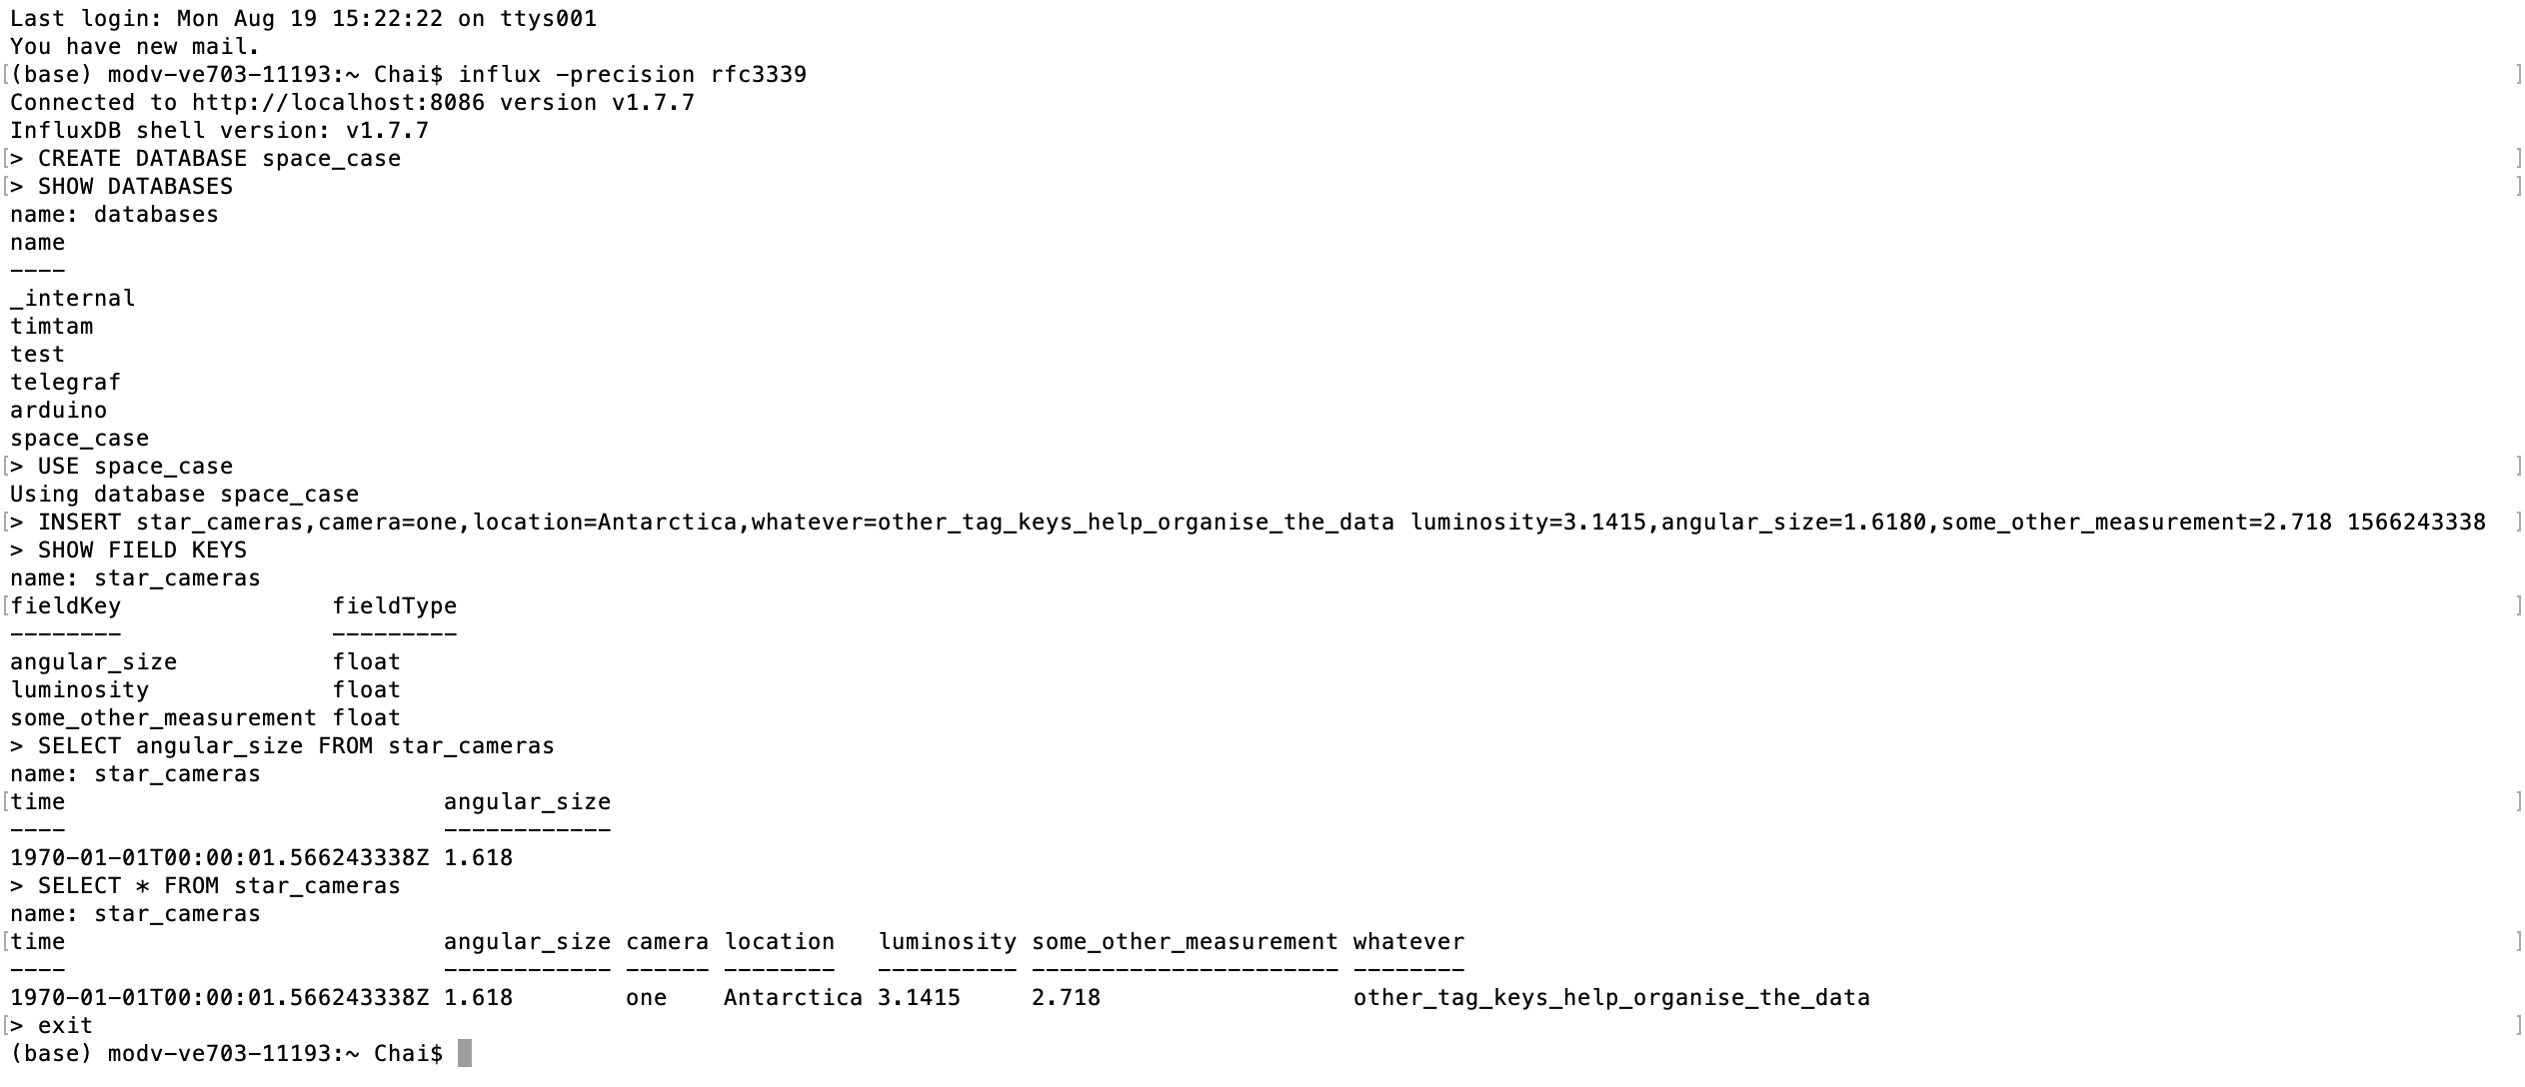

More information here:

<https://docs.influxdata.com/influxdb/v1.7/introduction/getting-started>

**How to Use Grafana**

Overview

Grafana works by plotting time-series data from a Data Source on a panel. Multiple panels for different data can be created to form a Dashboard.

Running Grafana

Open browser and go to <http://localhost:3000/> (3000 is the default port).

Default username is admin and default password is admin (you will be prompted to change the password after you first log in).

Adding Data Sources

The first thing you should do on Grafana!

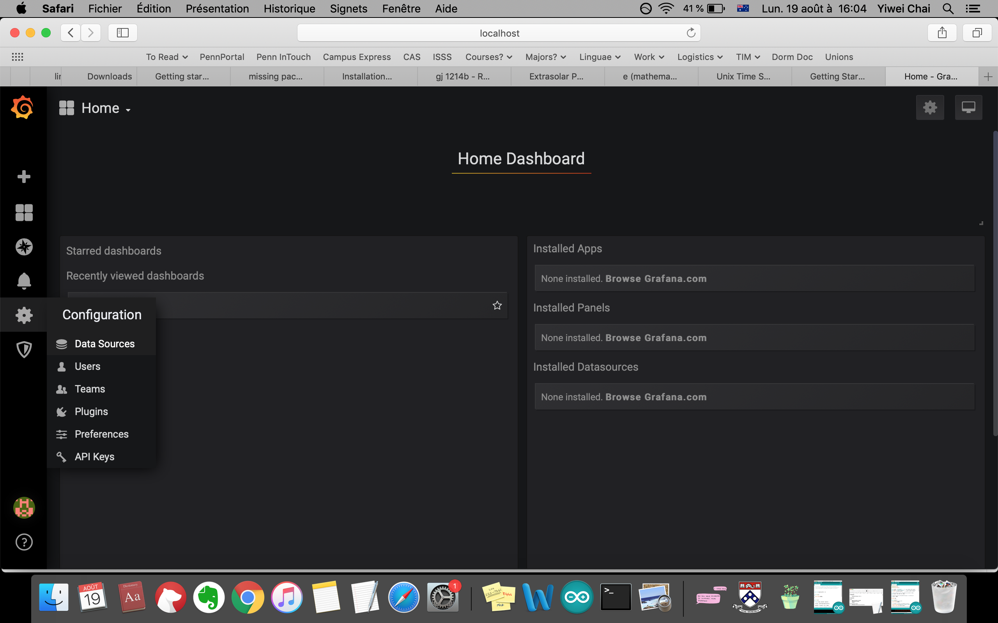

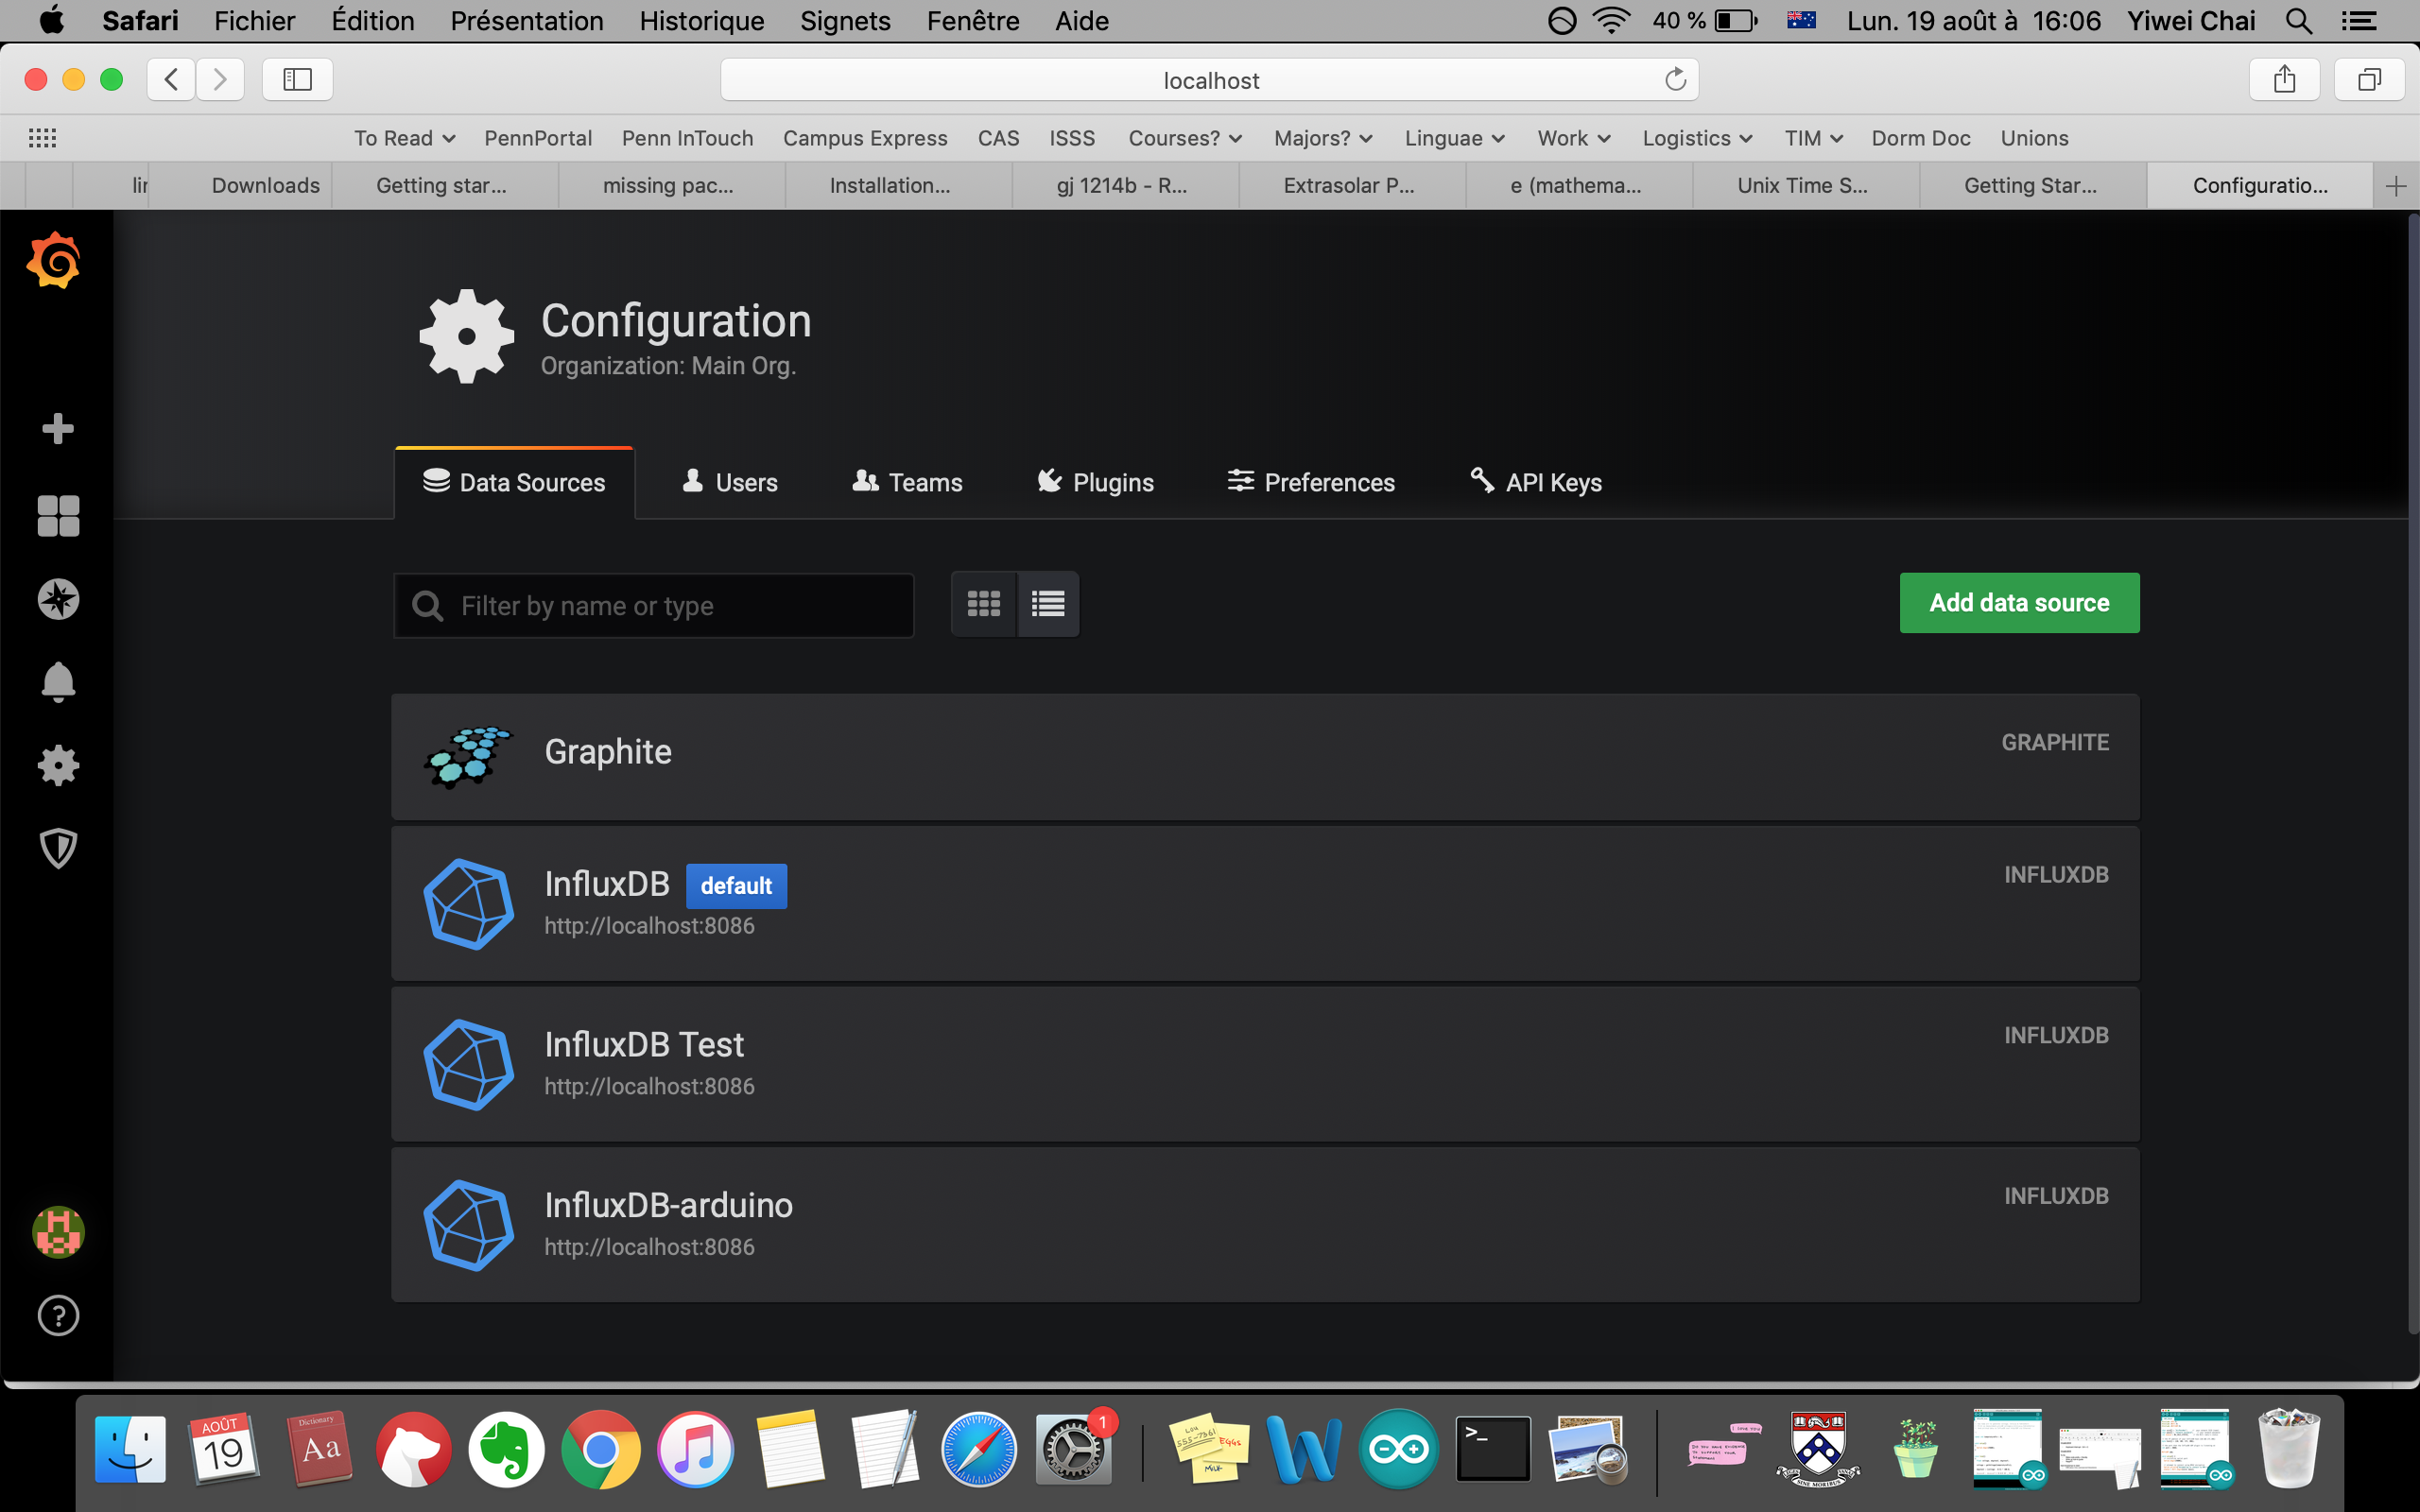

In this case, we’ll be using InfluxDB, but other data sources can be used if they make more sense for your operating system (e.g. Graphite commonly shows up in the Grafana screencasts, and works more easily on Windows than on a Mac).

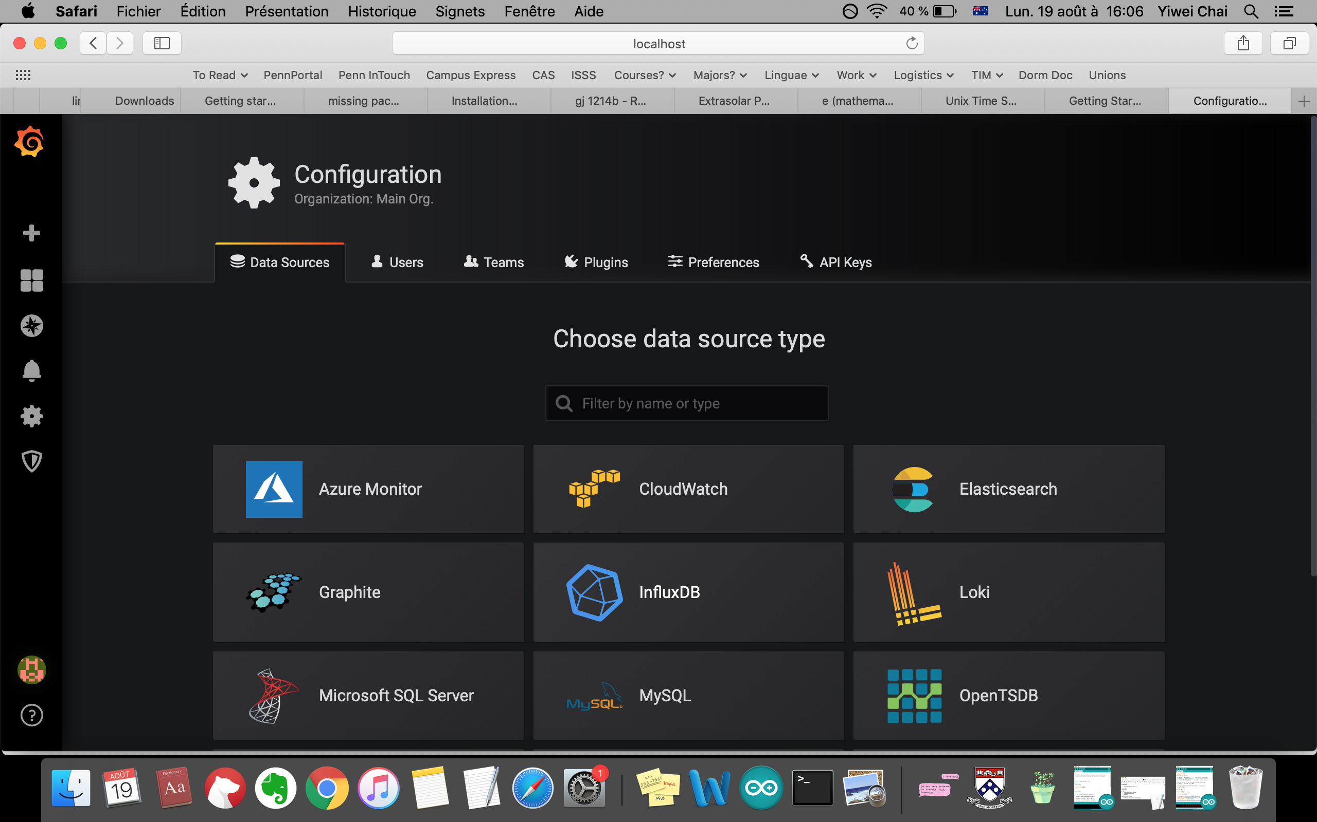

Enter desired information to set up Data Source; what is shown is just an example and can be tailored however you want.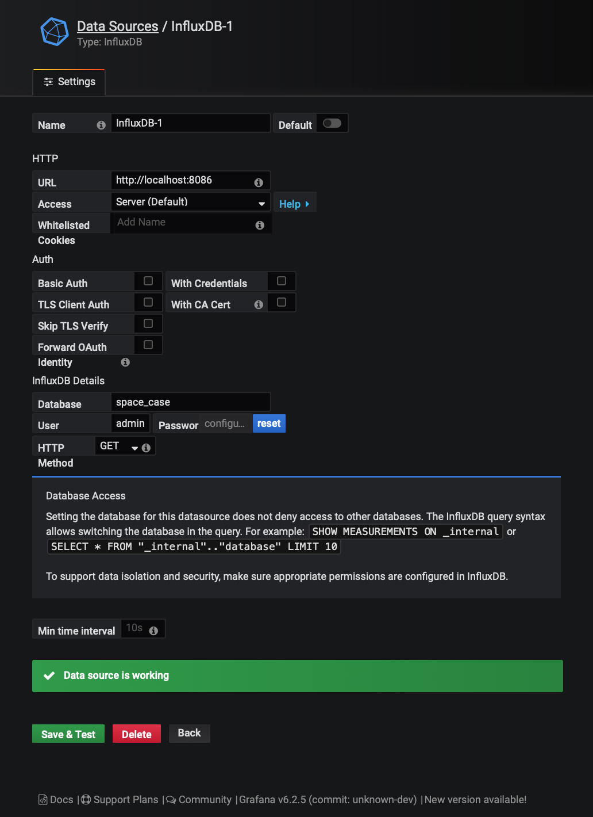

Creating Dashboards

Once you’ve got a data source working, you can begin to query and plot data on a Dashboard!

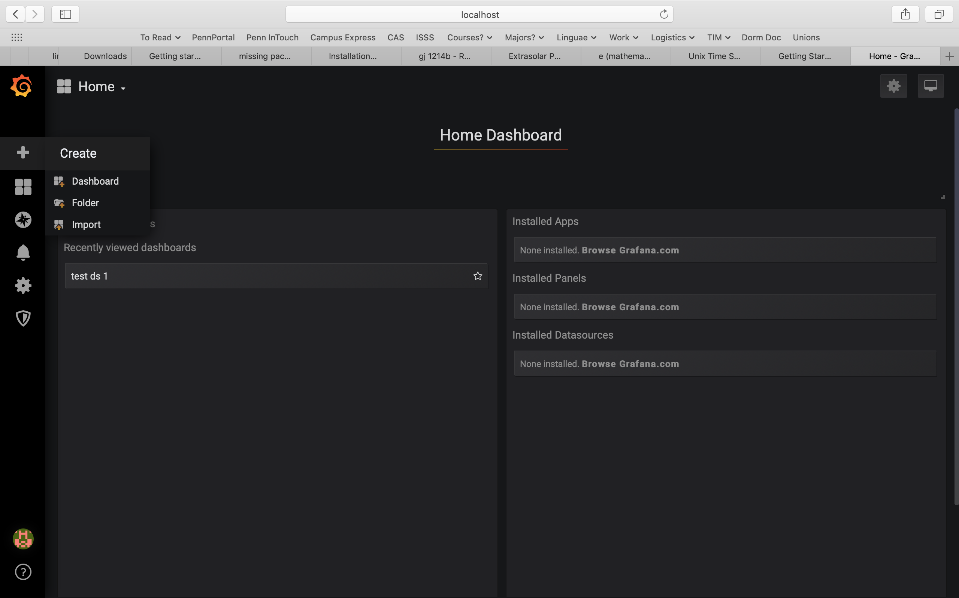

Add a query (note: you can do this as many times as you want per panel if you want to graph two (or more) things at the same time!)

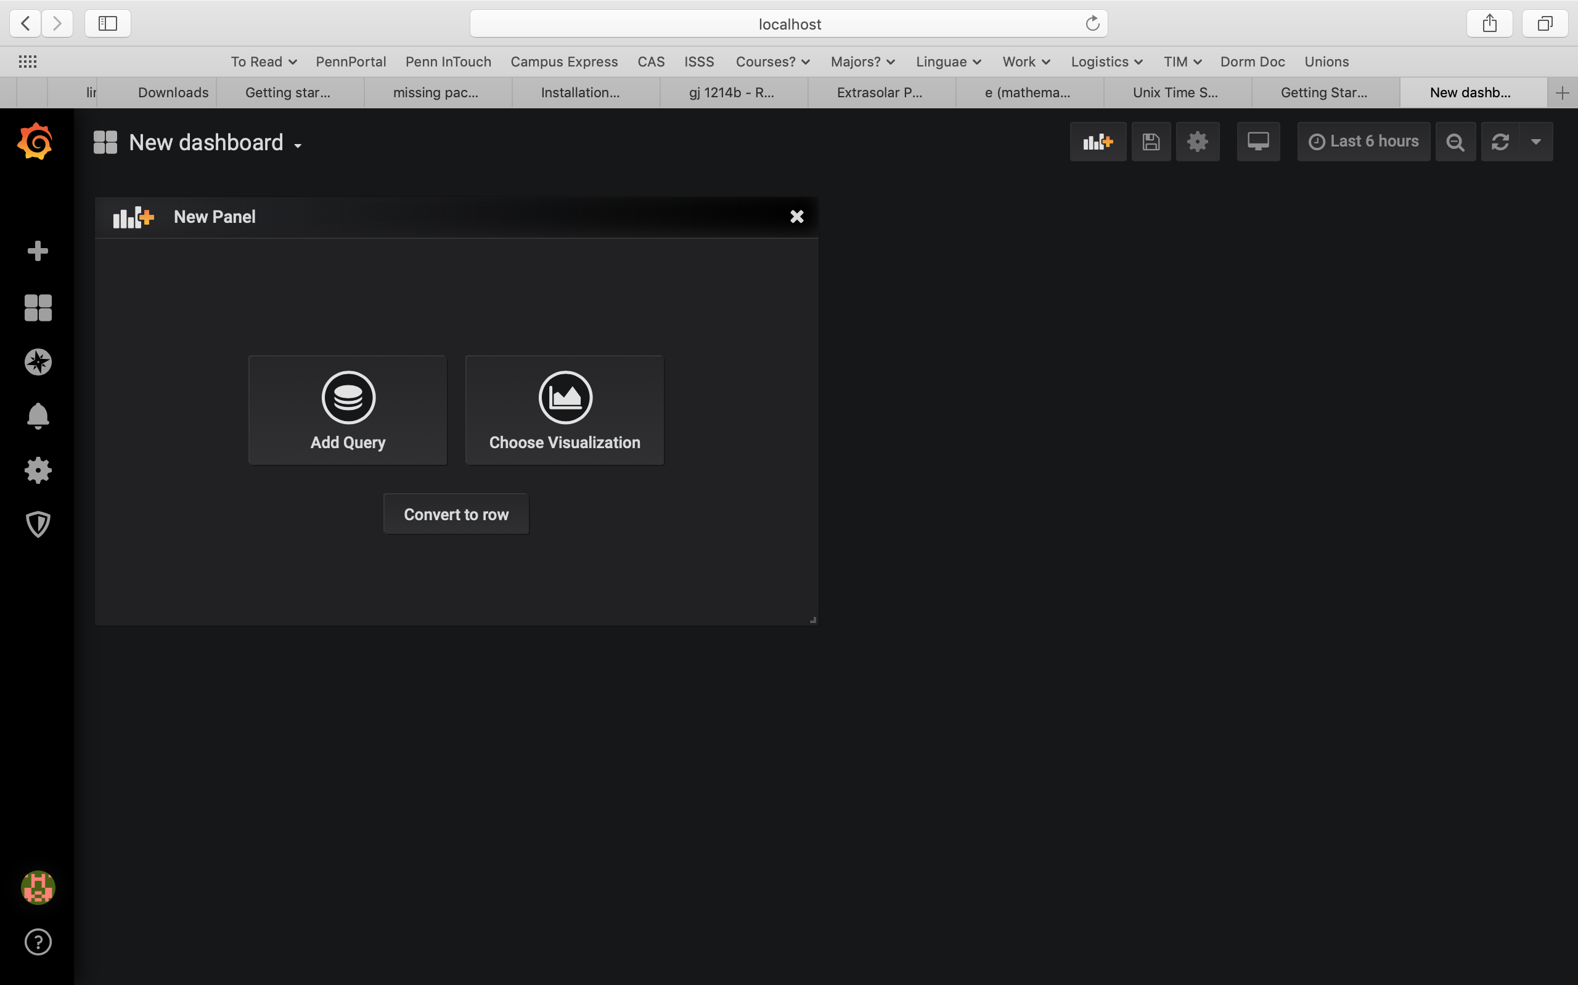

Select Data Source (will automatically select the Data Source you have set as your ‘default’, but here InfluxDB-1, the Data Source you just created, is selected)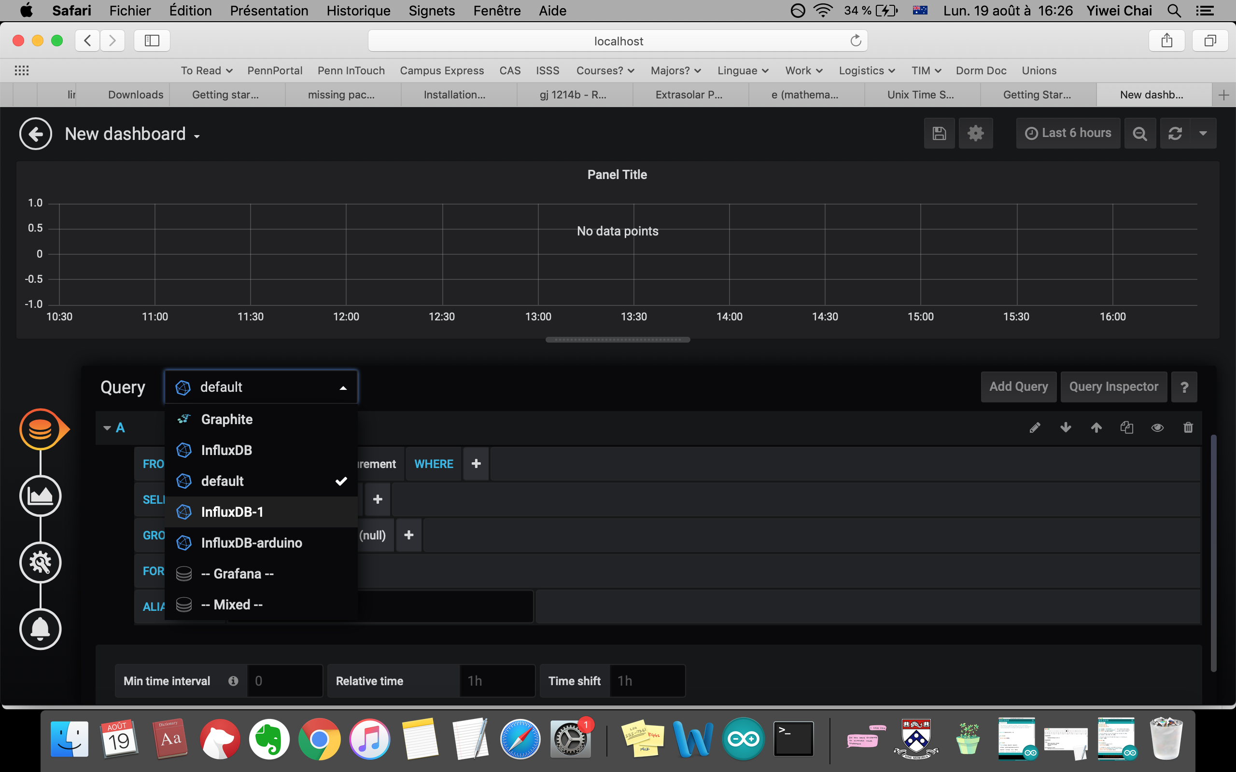

Select measurement (e.g. star_cameras)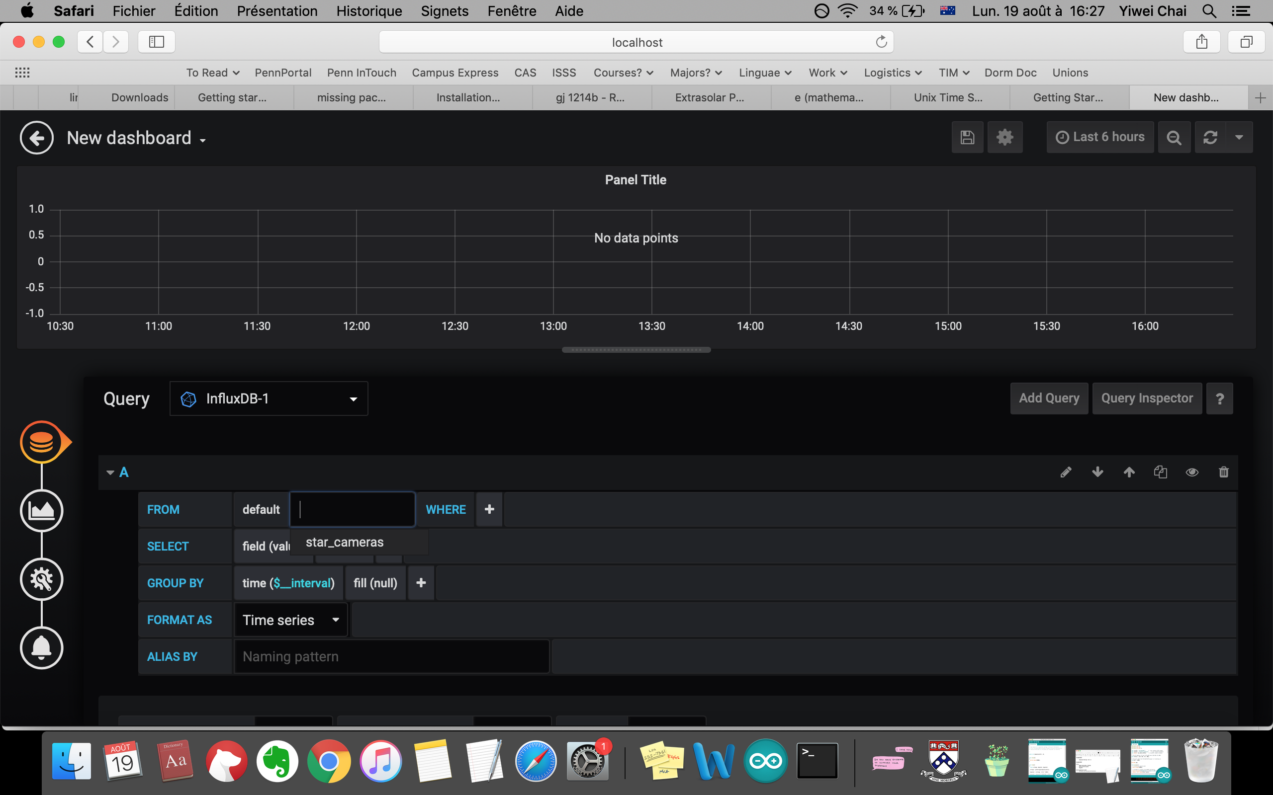

Optional: select tag key (e.g. location=Antarctica)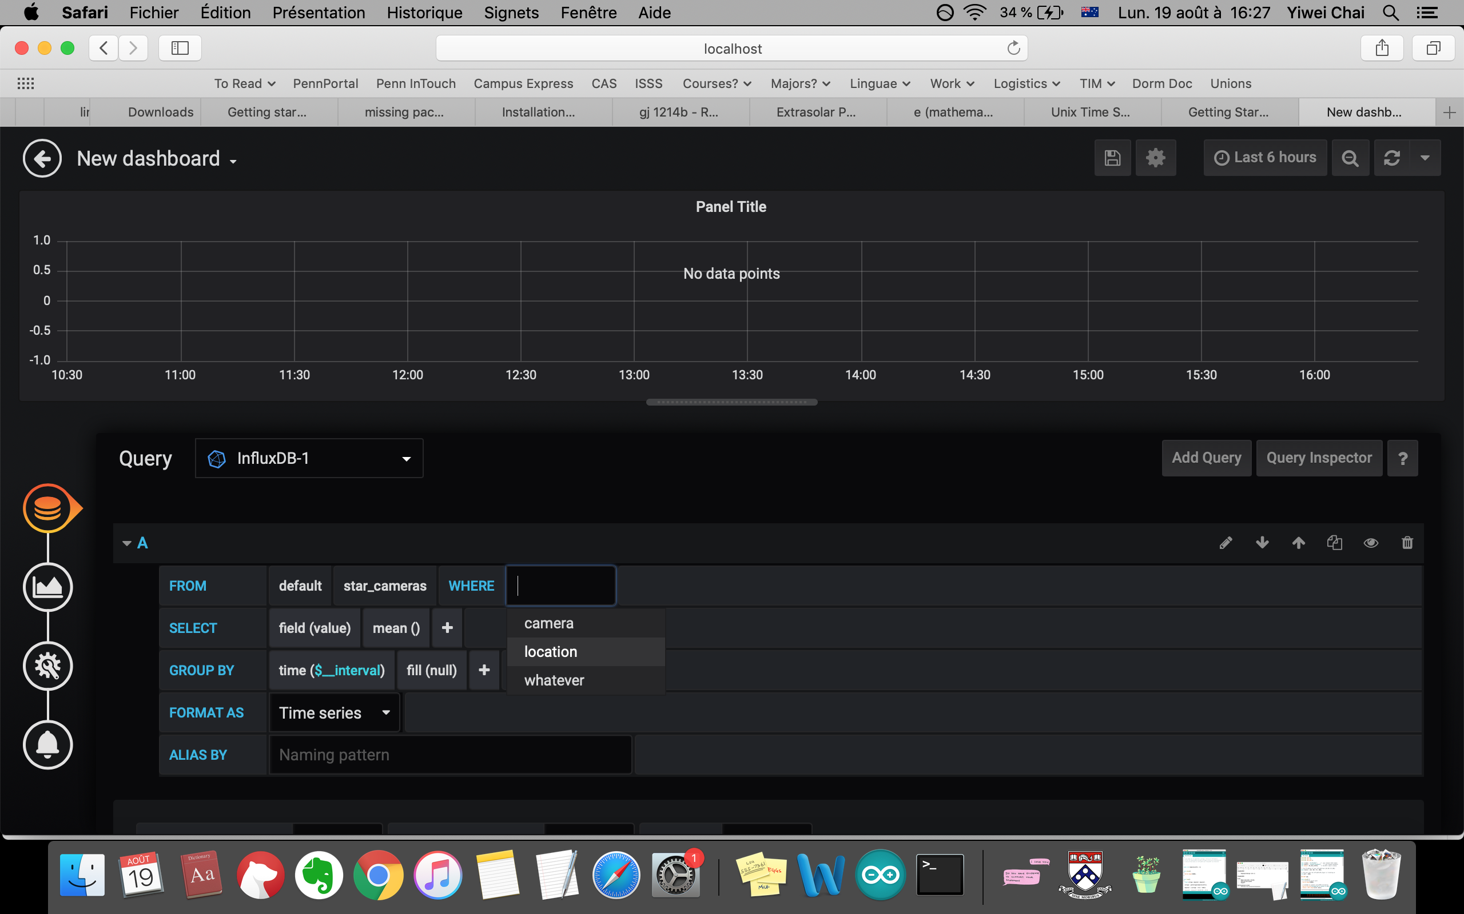

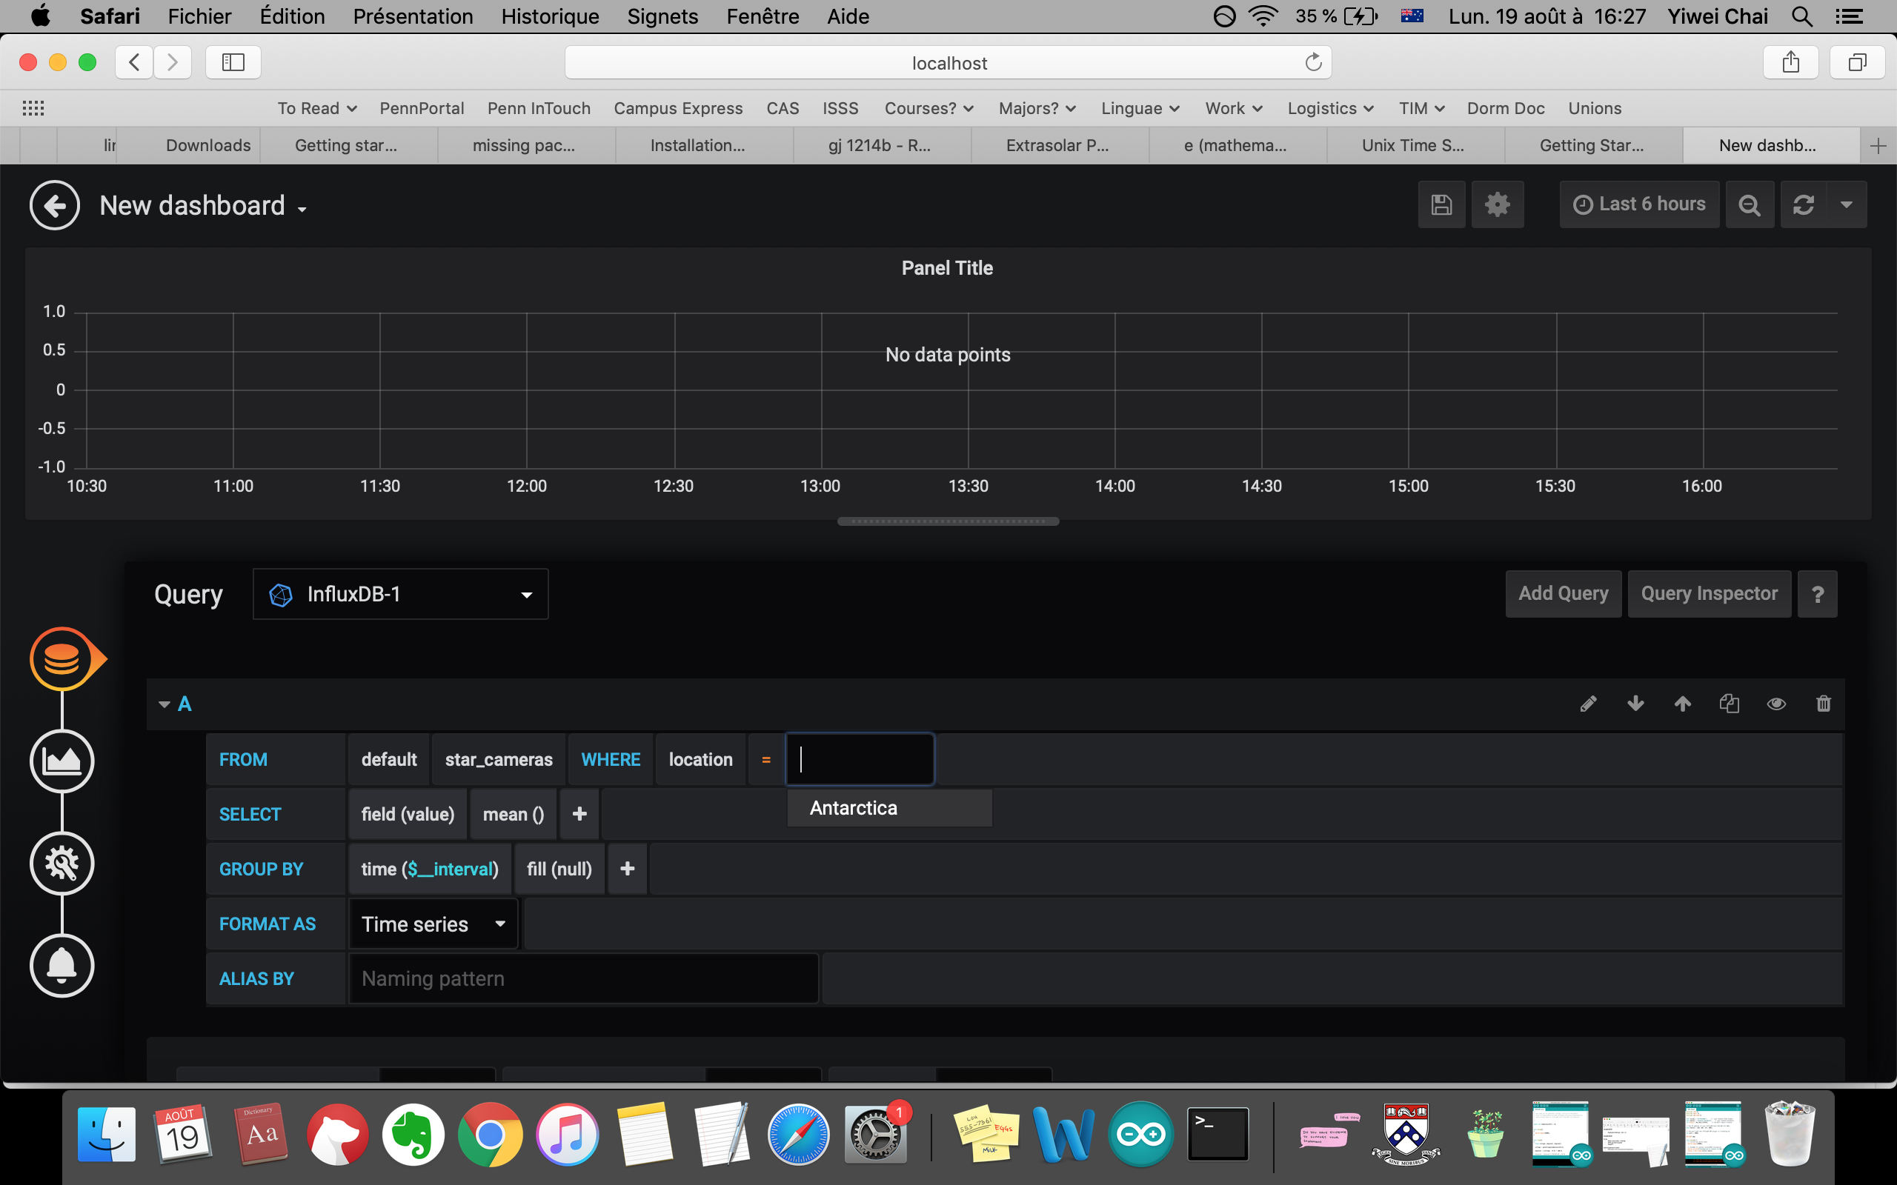

Select field key (e.g. luminosity) 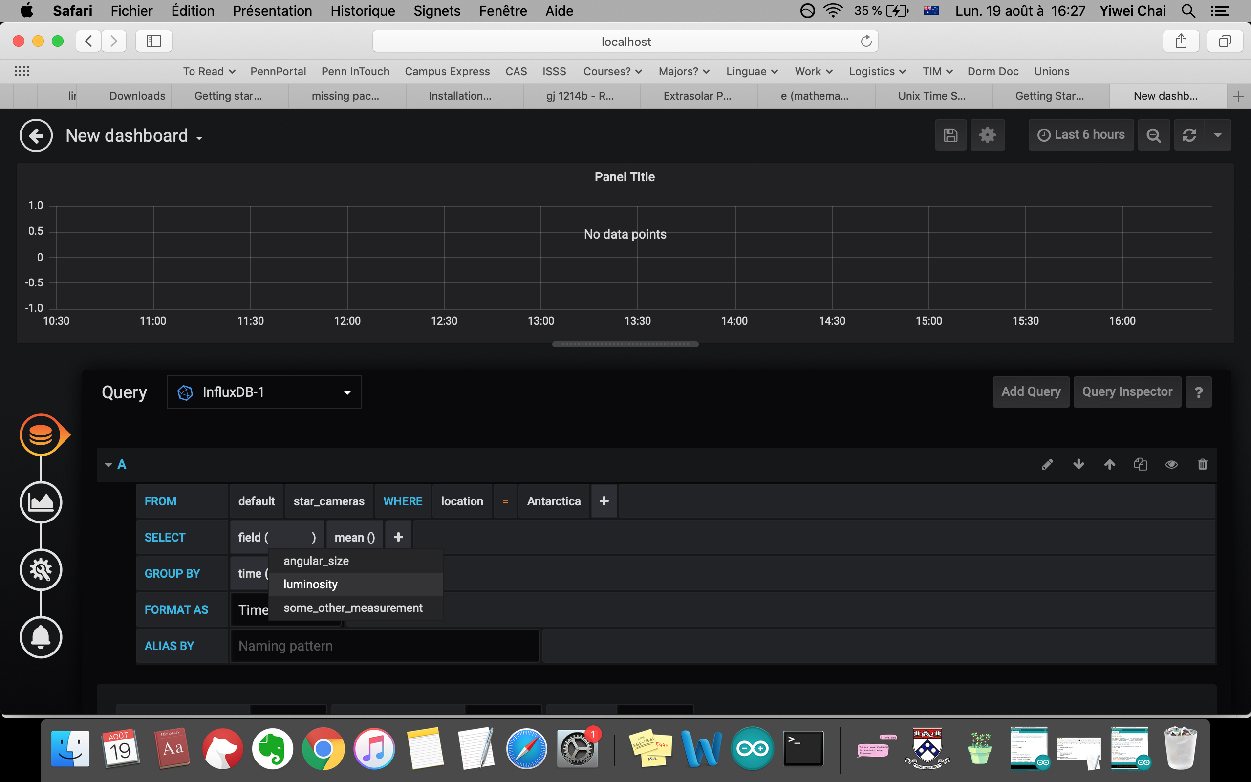

An example of all this, but with a database that has more than one data point:

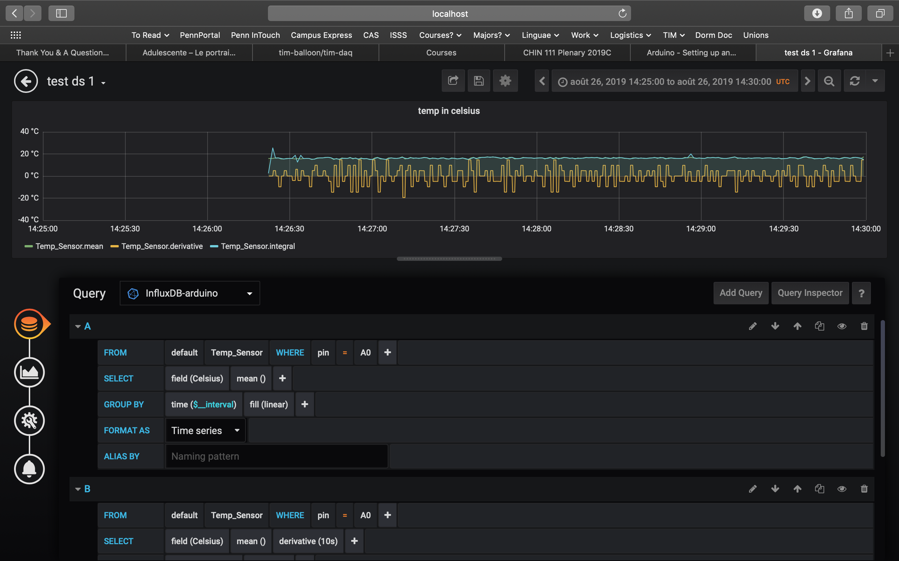

Some other cool stuff (using the above example):

* This allows you to adjust the time range on the x-axis (you can set specific times, or view all data from the past 5 mins, hour, day, month, etc.)
* This allows you to automatically refresh the panel, so you can track data in real-time!
* This allows you to add other queries (e.g. in this panel there are 3: A, B & C)

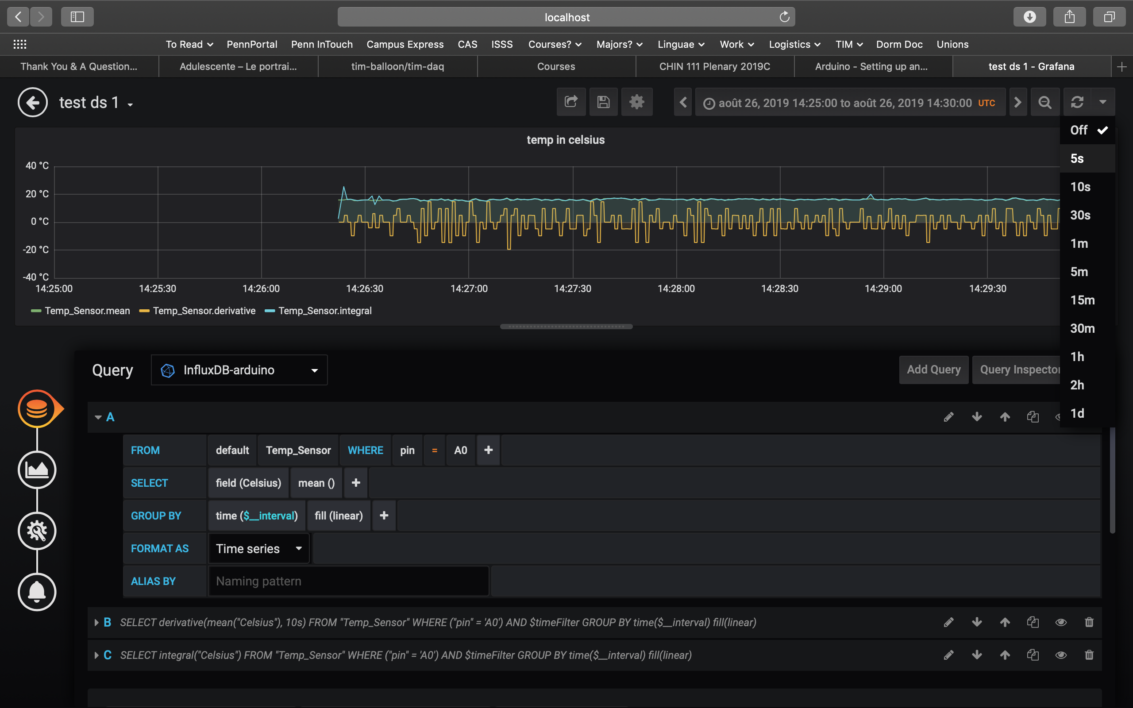

For more information on making things pretty and other neat tricks when building Dashboards:

<https://www.youtube.com/watch?v=sKNZMtoSHN4&list=PLDGkOdUX1Ujo3wHw9-z5Vo12YLqXRjzg2&index=7>

For more general information:

<https://grafana.com/docs/guides/getting_started/>